Notes 6: CSS Styling through Classes

**Introduction to Classes**

Classes and IDs are the two methods we have for naming sections or elements within a web page. As you will recall, we named the major sections of our page by creating divs, which we named with IDs. IDs may only be used once on any one web page. If I name one section of the page *banner*, I cannot refer to another section of that same page as *banner* although I may use it one time on any other web page. Since we would only ever include one banner or one footer on a page, it is appropriate that we named these regions with IDs.

There are many times that a designer may wish to apply a particular style more than once on a web page. In this case the designer would create a class, as classes may be used any number of times on a web page. As an example, if my page includes a repeating pattern of divs, I can create a class to appear like a CSS rule, then apply it to all of the other divs.

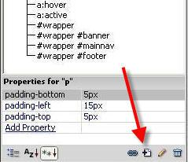To create a class in Dreamweaver:

1. Click the new rule icon at the bottom of the CSS pane.

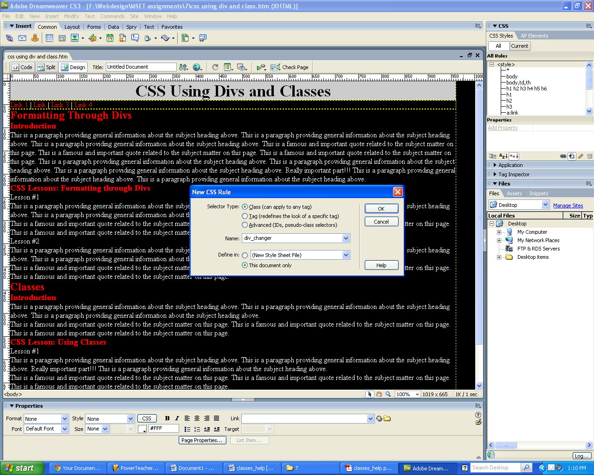

1. Change the selector type to “class”
2. Enter a good name for the class
   1. (do not use any spaces in the name)
3. Click “OK”

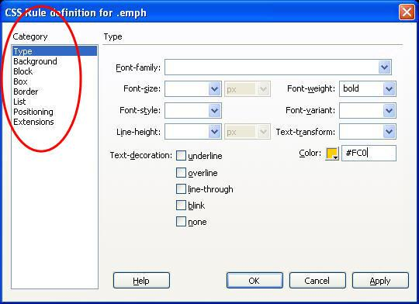

Much like a regular CSS rule, we can apply rules to the .class. These classes can be applied to any div, at any time. Choose properties for the class from the categories available. You can always add, remove or modify your settings later.

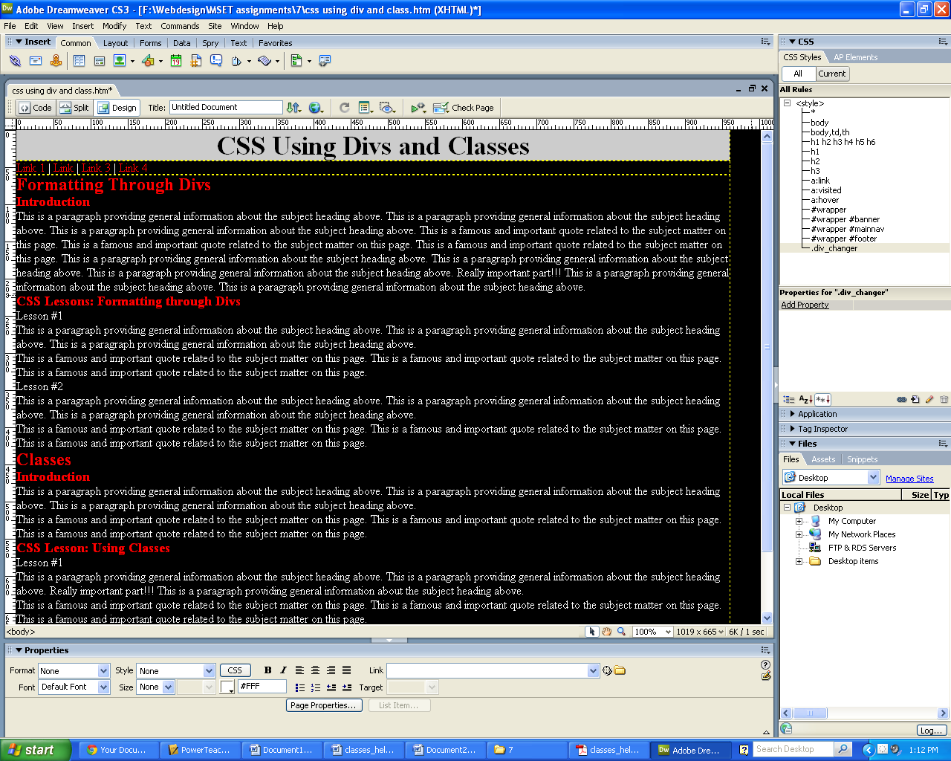

The class now appears in the CSS Style Pane. The new   
name appears as a .*name* rather than a *#name*

**To apply a class a div already made in your document**

1. Click in the div
2. Choose the class from the style dropdown in the properties pane.
3. Rinse and repeat until the website is complete!

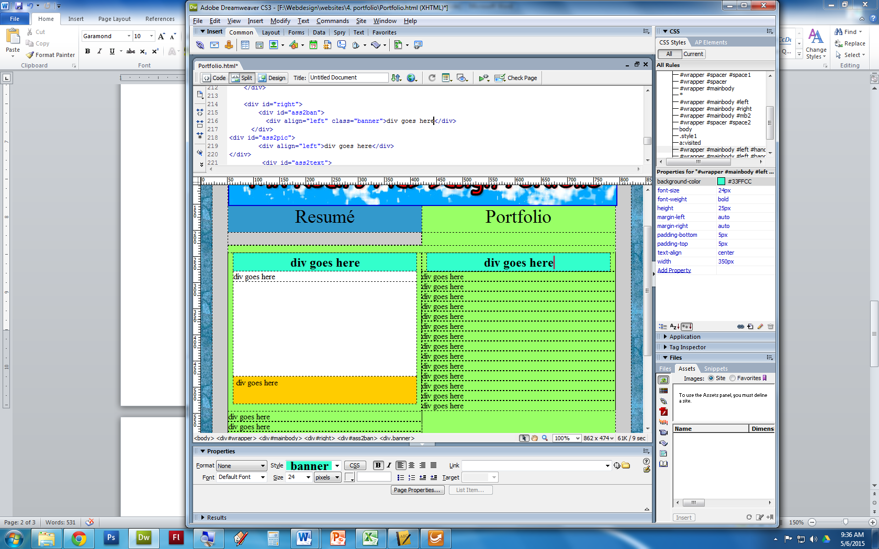

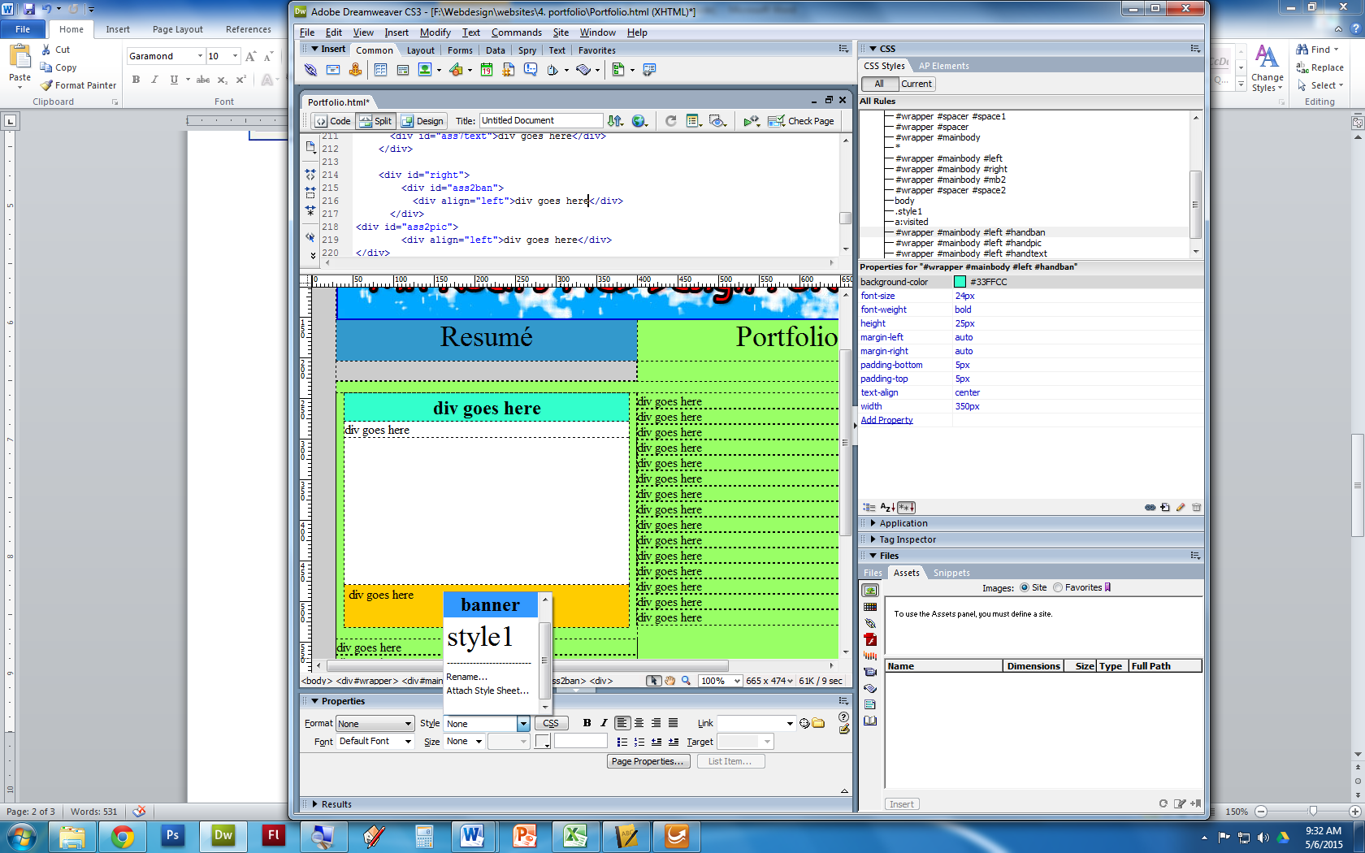

**To apply a class to a div (as you build the div skeleton)**

1. Insert the divs as normal
2. Use the class drop down to choose the class you may have already made |
3. OK.
4. This will apply the class style to the div as you entered it. This will GREATLY decrease the overall time needed to complete a website, if done correctly

Note *– Dreamweaver will most likely not select the class you select the first time you* *select it. This is a glitch in the program. You will probably need to select it a second time.*

